** Welcome@Mars**

**Welcome@Mars comes with three set of applications –**

1. Welcome@Mars Registration App
2. Welcome@Mars Pre-Registration App
3. Welcome@Mars Admin App
4. **Welcome@Mars Registration App**

Registration App will enable visitor registration, picture capture as per each site’s configurations and will reduce manual work of front desk personnel by notifying the host they are meeting directly.

This app can be used by Mars Associates, Mars Contractors and External Visitors. On arrival, all visitors will provide their email ID, which the app verifies through Microsoft Azure Active Directory (Azure AD).

Post that visitors need to enter their details & selects host and sign a non-disclosure agreement form to complete the check-in process. In addition to this, external visitors need capture their picture based on their visiting site configurations.

Select your site from the first screen (Select Our Site) and then setup Camera (Front / Back) as per device configuration from subsequent screen.

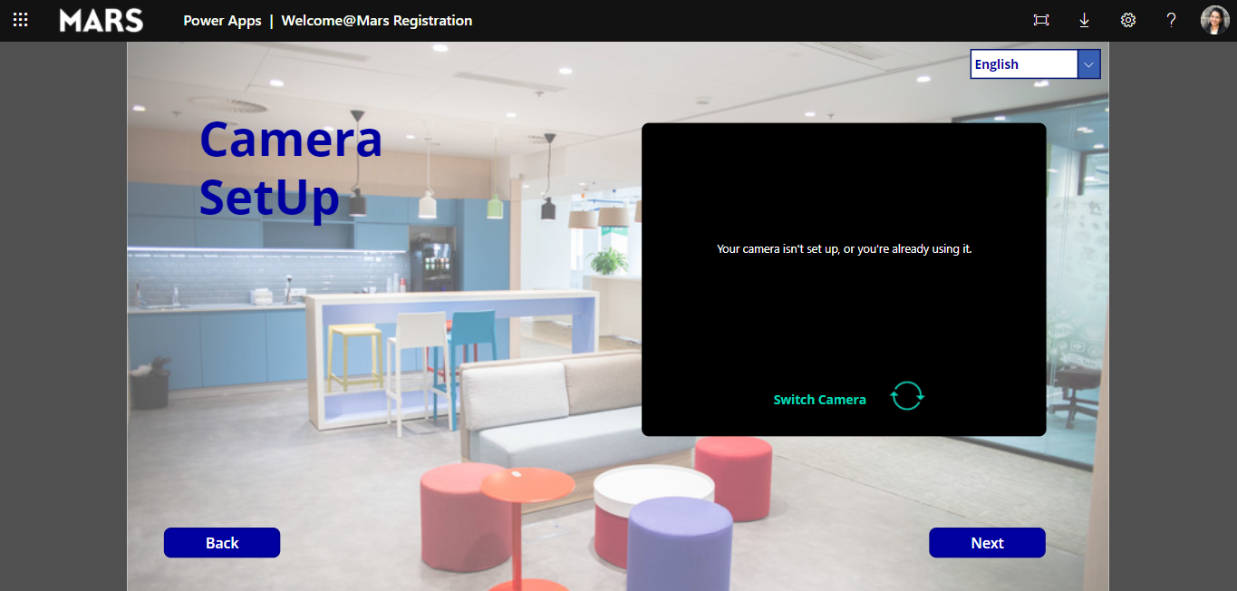

Visitors will be entering their email address on their arrival –

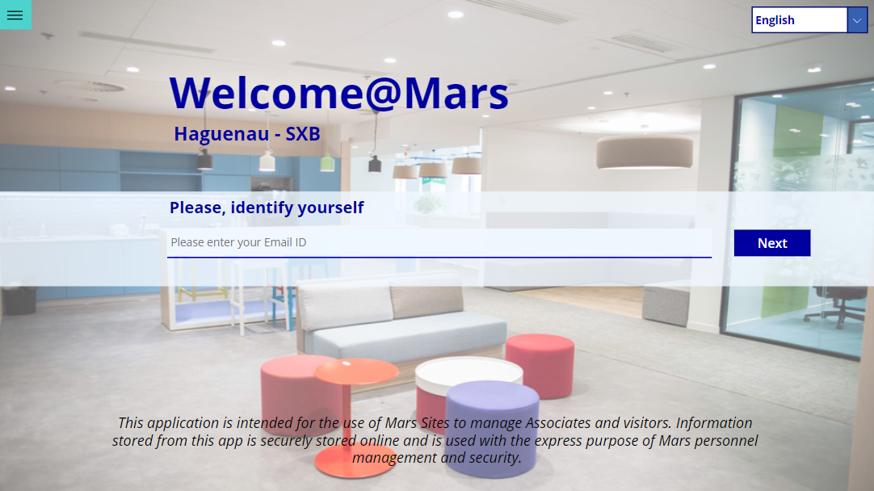

Visitor details will be fetched from Mars-AD for Associates and Contractors. External Visitors need to fill out their details here. All pre-registered visitors will have their basic details and host auto-populated as per pre-registration data.

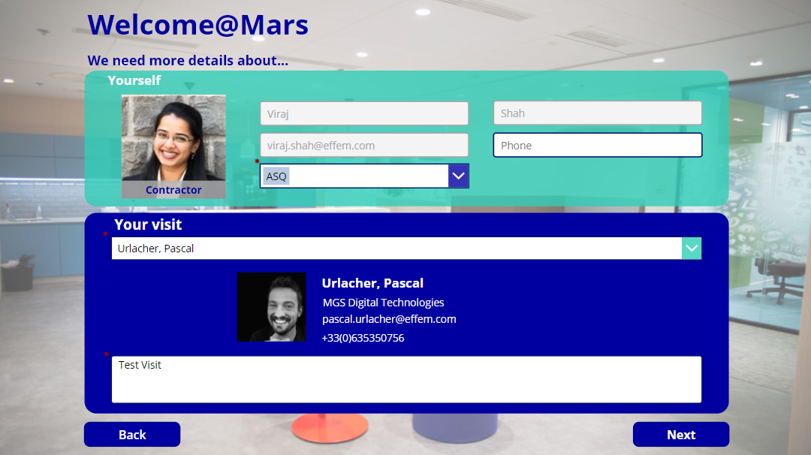

Host will be notified by Teams and Email once registration is completed for visitor.



1. **Welcome@Mars Pre-Registration App**

Pre-Registration App will help hosts to pre-register their visitor’s visit well in advance to enable visitors with smooth and fast check-in process at the time of arrival at site. This application will be accessible to all Mars associates. Notification mail will be sent to each visitor with their visit and host details.

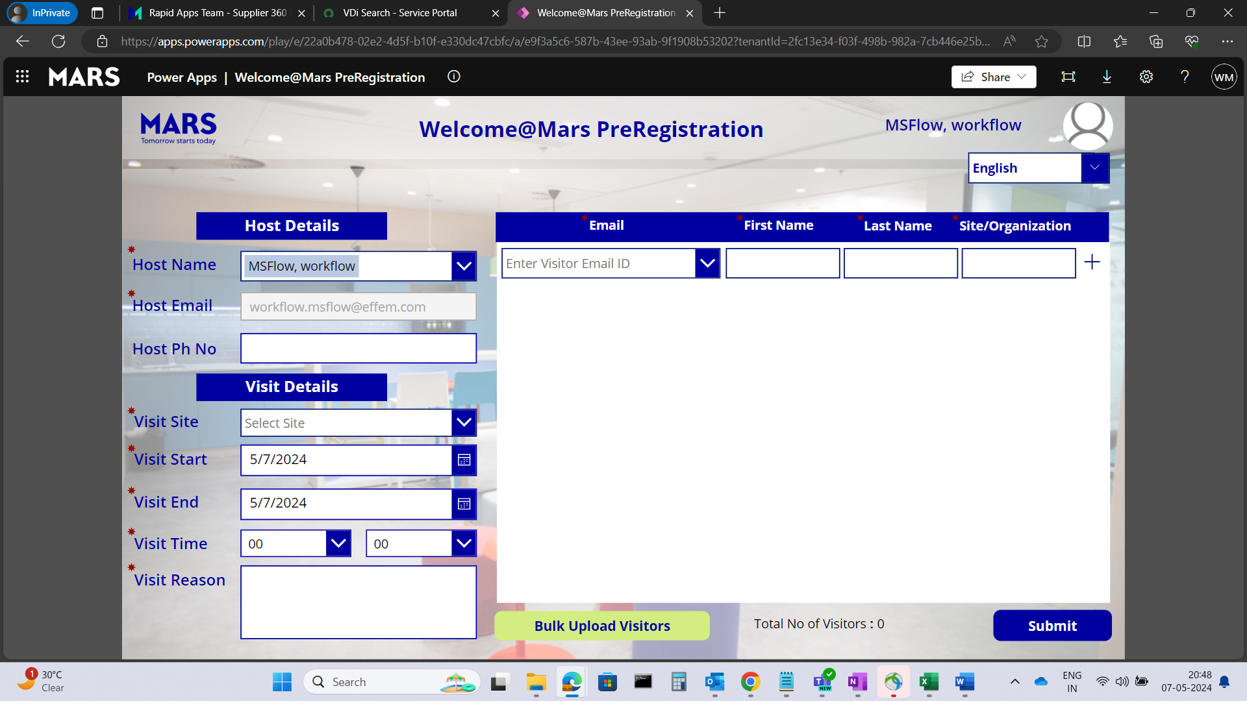

1. **Welcome@Mars Admin App**

Admin App will be place for Site Admin to manage site configurations, view registration and visitor details for the site and manually check-out visitors.

